The purpose of this document is to explain the Waiting List procedure and the basic principles behind it, to ensure that a consistent and transparent approach is taken and that the Waiting List is not open to abuse.

The Waiting List Co-ordinator implements this procedure, and acts at the will of the Committee. The Waiting List Co-ordinator may delegate responsibilities, or share duties as a team.

This document has 2 sections:
1. Basic Principles (1 page)
2. Waiting List Procedure (2 pages)
Basic Principles to the Waiting List Procedure
The basic principles to the RAHA Waiting List are:

- The Waiting List is managed by the Waiting List Co-ordinator.

- There is no right to assume tenancy of a plot other than via the Waiting List:
- Members may not sublet any part of their plot (RAHA Rule 9g)
- Plot sharing is only permitted at the point of taking on a plot and details of all sharers must be recorded. If one of the sharing Plot Holders leaves that plot then the remaining Plot Holder becomes the sole Plot Holder for this plot. Only one of the sharing Plot holders is the nominated contact with the RAHA.

- Sometimes Plot Holders are helped by family or friends. Those helping out cannot take over the plot at the end of the Plot Holders tenancy except via the Waiting List Procedure. The Committee Member must make sure that those helping understand this and encourage them to join the Waiting List.

- People will only be added to the waiting list if their address is in Romsey Town, Woodley, Whitenap or Abbotswood (See Map at end of procedure). If there are many more vacant plots than people on the Waiting List this catchment area may be expanded on a vote by the committee.

- The Waiting List is sequenced by date of application, with the earliest application at the top of the list.

- The Waiting List has 2 kinds of applicant: people who will accept any plot and those who will only accept a specific one. The person at the top of the Waiting List will be offered the vacant plot even if someone lower down has specifically requested it.

- There is a limit of 20 rods (500 square metres) per household. An existing tenant may apply for additional plots as long as the total area of their plots does not exceed 20 rods (500 square metres). Newcomers to allotments/gardening are usually offered 5 rods (125 square metres) to start with.

- Applicants have the right to refuse 3 allotment offers. Three refusals will result in being placed at the bottom of the Allotment Waiting List.

- An existing plot holder who is on the Waiting List and not looking after their plot will not be offered a vacant plot.

- If an existing Plot Holder who is also on the Waiting List is given Notice to Quit then their name will be removed from the Waiting List.

 end of RAHA Waiting List Basic Principles 
Waiting List Procedure

- Anyone wishing to go onto the RAHA Waiting List may complete the application form that is on the Welcome page of the website (http://www.romseyallotments.org.uk/). Verbal or written applications may be accepted if all details are given.

- The Chair receives notification of the application from the website and forwards it to the Membership Secretary.

- The Membership Secretary adds the applicant details onto the bottom of the Waiting List.

- When a plot becomes available the Plots Inspection Co-ordinator notifies the Waiting List Co-ordinator and Membership Secretary.

- The Waiting List Co-ordinator uses the Waiting List to determine who to offer the plot to, using the prioritisation stated in the “Basic Principles” above.

- The Waiting List Co-ordinator contacts the applicant to verify that they are still eligible for, and interested in, a tenancy. If so the Waiting List Co-ordinator show the applicant the plot at the earliest opportunity. The applicant has up to 2 days from the date of the offer to consider taking that plot and after that time is then assumed to have rejected that plot.

- If the applicant accepts the offer of the plot then:
a. The Waiting List Co-ordinator notifies the Membership Secretary and Chair with details of the plot size and number and the applicant details.
b. The Membership Secretary sends the applicant a welcome letter, which includes details of how to pay.
c. The Membership Secretary adds the applicant's name and details to the Membership List.
d. The Membership Secretary sends the Treasurer the applicant's details plot size and number and details of the vacating plot holder.
e. The Treasurer contacts the applicant to arrange payment of deposit, rent and (if the applicant is a new member) membership fee.
f. The Chair adds the applicants email address to the contacts list on the RAHA email system.

- If the applicant does not wish or is not in a position to accept the plot first offered then the Waiting List Co-ordinator notes this and the applicant's place is kept at the top of the Waiting List for the next vacant plot. If the third plot offer is also rejected, the applicant's name is moved to the bottom of the Waiting List.

- If an applicant rejects a plot the Waiting List Co-ordinator will begin again at step 6 of this procedure to identify the next applicant to offer the plot to.

- When a Notice to Quit is issued the Membership Secretary will check the Waiting List and, if the Plot Holder is on it, will remove them from the Waiting List.

Map of RAHA Catchment Area for Plot Applications

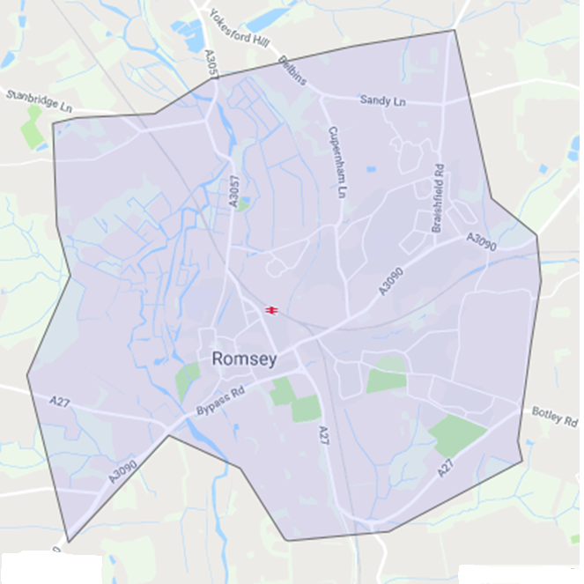

 end of RAHA Waiting List Procedure

